Project Design Phase
Solution Architecture

Date | 29 -11-2025
Name | Sathish kumar s
Project Name | DocSpot
Maximum Marks | 4 Marks

Solution Architecture:
The Solution Architecture of DOCSPOT ensures a secure, scalable, and efficient healthcare appointment management system. It connects patients, doctors, and admins through a structured MERN-based platform designed for fast access, reliability, and real-time appointment handling.
- provide an intuitive interface for finding and booking doctors
- Ensure real-time availability of appointment slots
- Maintain secure authentication for users and doctors
- Offer admin-level control for platform management
- Enable fast and reliable API communication
- Support future scalability for telemedicine & payments

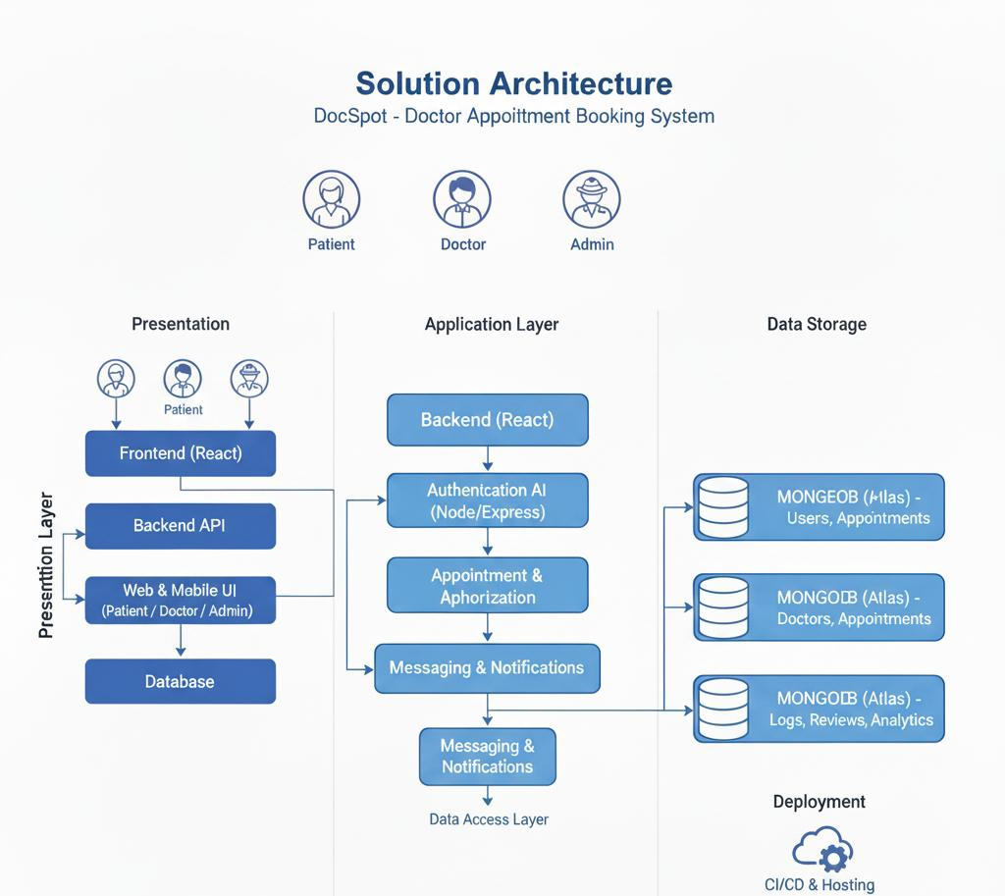
Example - Solution Architecture Diagram:

